**Initial Design & Game Treatment**

Goldrush

Victor GANTER – 2926840

Melchior GARRIGUES – 2927207

Valentin FEREY – 2926392

Galdan MOULINNEUF – 2927686

**Inspiration**

We got the idea of a strategy game from “Risk”. We wanted to make a risk-like game but adding new features and less luck when it comes to fight.

That’s why we added different type of units that can be created thanks to resources and upgraded temporarily thanks to the gold.

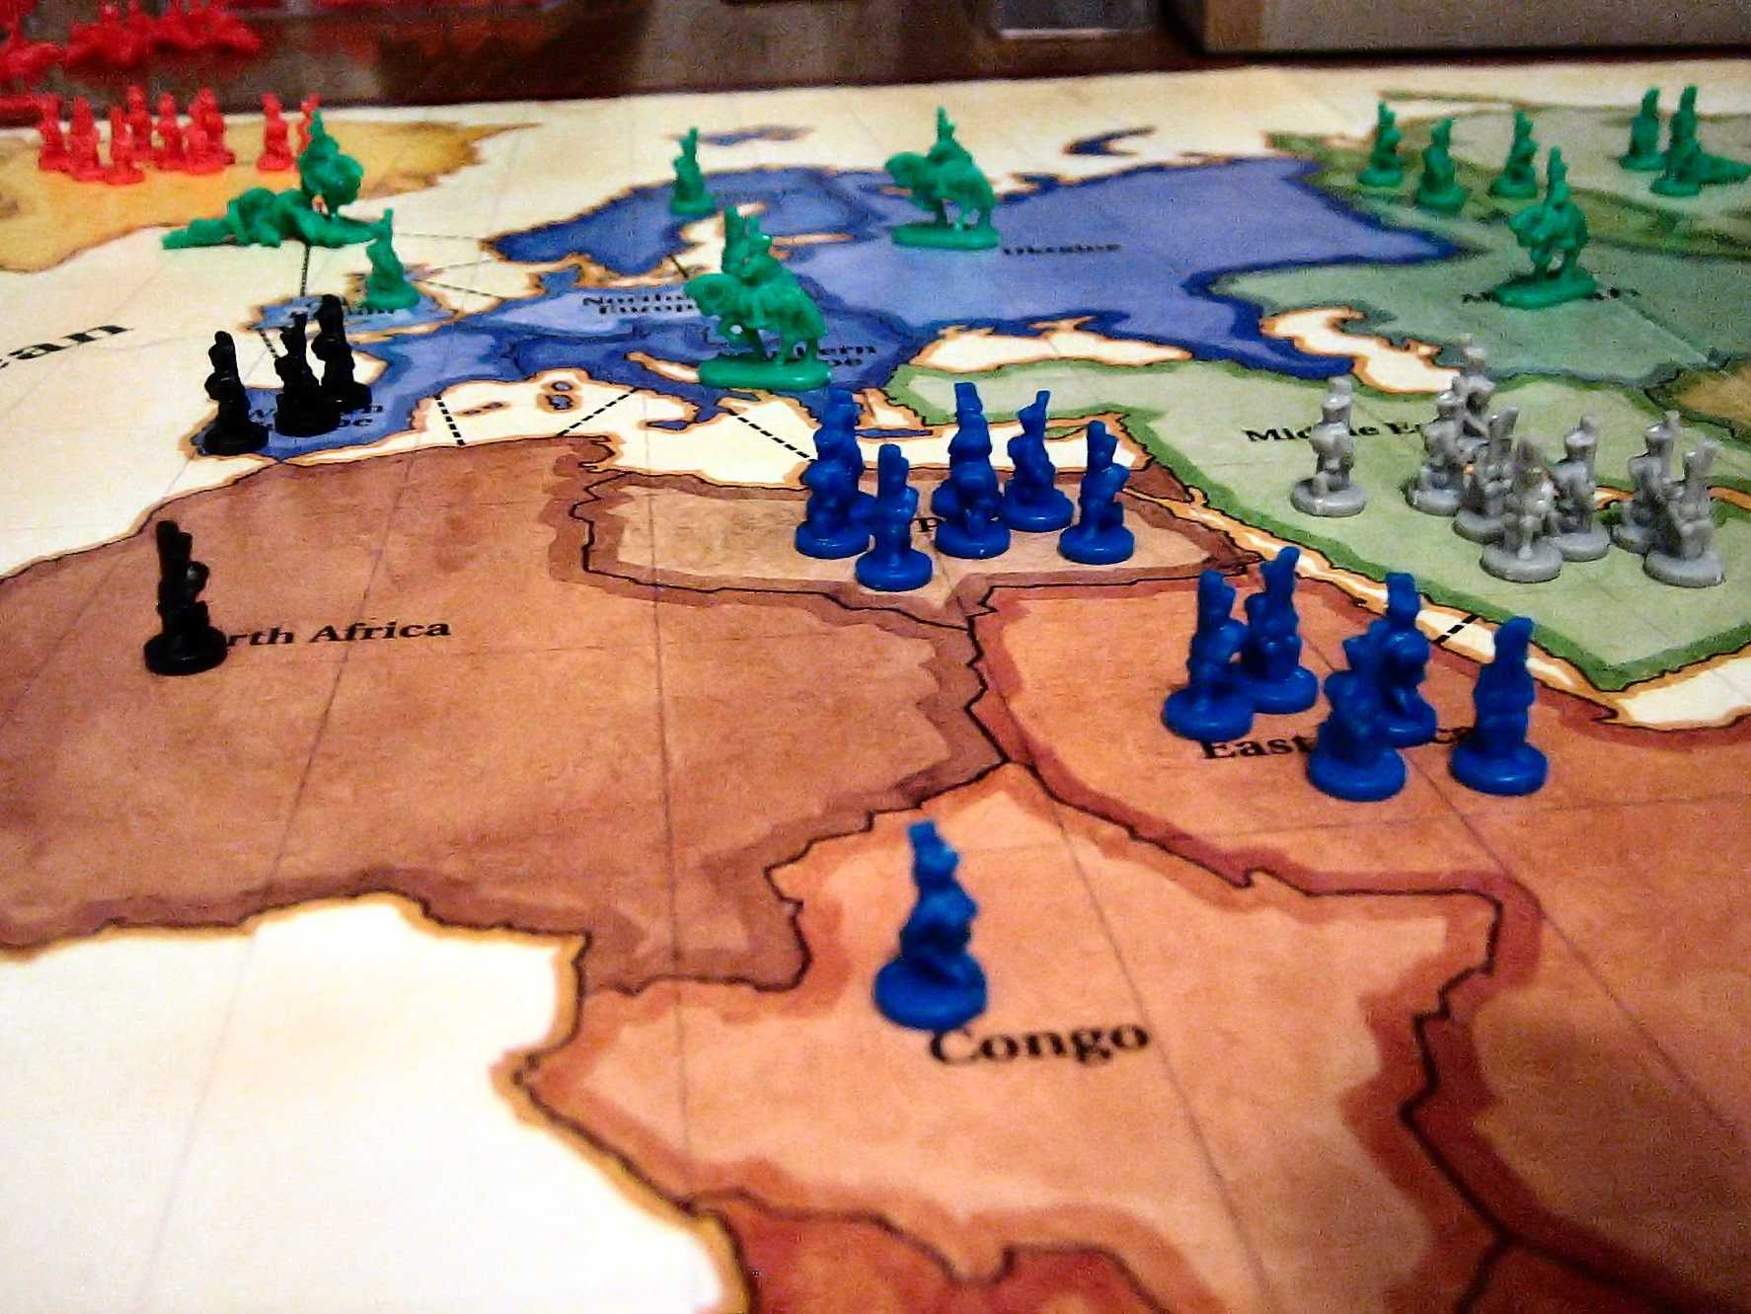

About the fights, we were inspired from turn-based RPG games like “Final Fantasy VII” or “Might and Magic”. The concept of three units that counter each other came from the “rock-paper-scissors” game to balance our game, but it also a common mechanic used in Real time strategy games, for example in “Warcraft 3” units have differents types of armor, and attacks are good against certain types of armor.

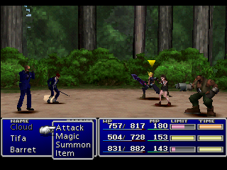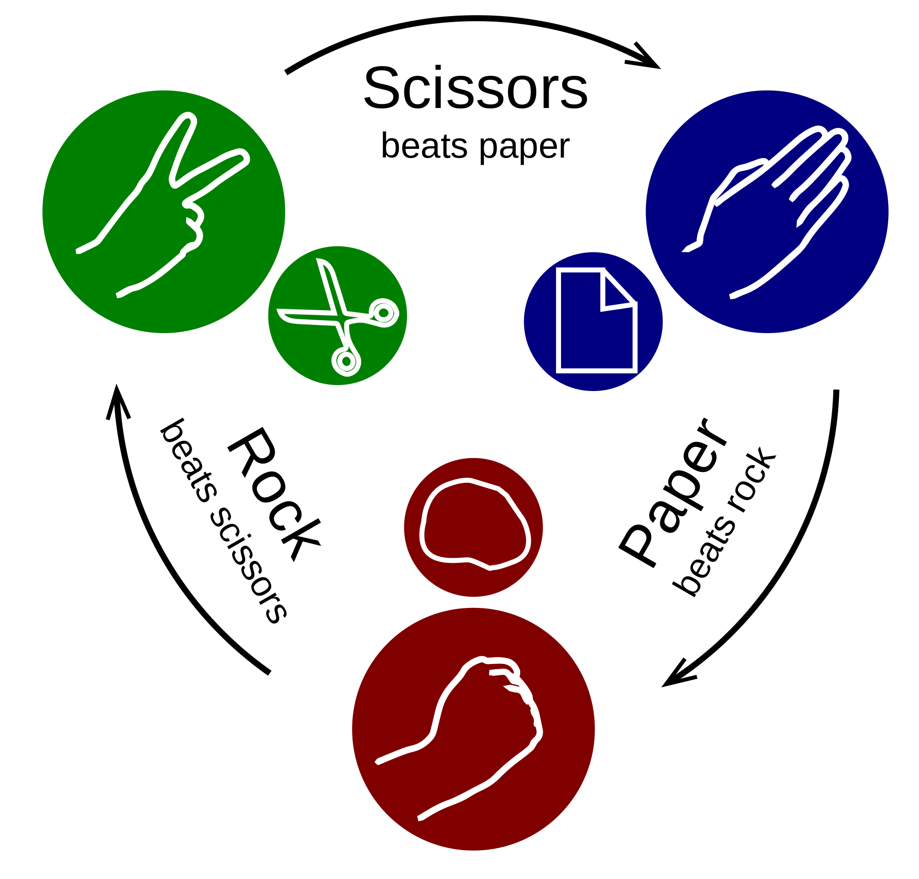

Another great difference from Risk come in the creation of battle units. In Risk, a conquered territory means “created units”. In Goldrush, a conquered territory means “you get one resource”, that’s why it’s very important to diversify your conquests. If you only have territories that produce Food, you will never be able to create units.

|  |  |  |  |
| --- | --- | --- | --- |
|  | Wood | Food | Iron |
| Cavalry | 0 | 2 | 1 |
| Archery | 2 | 1 | 0 |
| Infantry | 1 | 0 | 2 |

**How to Play**

To play is pretty much like Risk there is four main phases that are played turn by turn.

* Gather the resources
* Create units with the resources
* Fights other players
* Move units

Each territory gives one resource of it’s own. Gold can only be obtained by rolling the dice.

Units you create can go anywhere as long as the territory is yours.

You can only fight a territory that’s adjacent to one of yours (only the units of this territory will be able to fight).

You can move your units on your own territories and they must be adjacent.

**Game Feel**

We wanted the players to feel smart like in a chess game. They have to visualise the whole game and predict your opponent’s future actions.

Of course we wanted them to have fun playing it and the turn-by-turn system helps in that way. Even if a player isn’t involved in the fight, he can still think in a way to win the fight if he was in this position.

Maybe some players will unite temporarily to defeat another player and maybe there will betrayals.

That’s what Goldrush is about : Enjoying the Thinking.